- Preparation of buffers and solutions

- Phosphate-buffered saline (PBS) buffer:
Prepare PBS buffer pH 7.4, 10x or above (Final concentration 1x will be used). Preparation of 1000 mL 10x PBS (pH 7.4):
1. Na₂HPO₄: 29g
2. NaH₂PO₄: 5.24g
3. KCl: 2g
4. NaCl: 80g
Add deionized water up to 1000 Ml

- Tris buffer: Preparation of 50Mm Tris buffer (10mM will be used):

Add 0.3025g Tris in 40ml distilled water

Adjust pH at 7.4 with HCl

Up to the mark 50ml with distilled water

- Preparation of Protein solution

a) Each tube contains 1/0.5/0.32mg of lyophilized protein powder.
b) Add 1/0.5/0.32 mL of prefiltered (using a 0.2 μm membrane filter) deionized water and leave them for a few minutes on ice at 4°C in refrigerator to completely dissolve.
c) Filter them with a 0.2μm membrane filter.
d) Measure the concentration of protein stock using a Nanodrop. (Final stock conc. of protein will be 1mg/ml)

- Immunization scheme
Mice be collected from authorized organization, adjust mice with lab environment for one week, experiments then be carried out according to the design. Maintain room temperature at 25°C throughout the experiment for better outputs.

- 1st dose at day 0, three blood samples be collected at 7,14 & 21 days.
- 2nd dose at day 28, three blood samples be collected at 35,42 & 49 days.
- 3rd dose at day 56, two blood samples be collected at 63, 70 days.
- Mice sacrificed at 77days. Heart blood (whole blood) and spleen be collected.

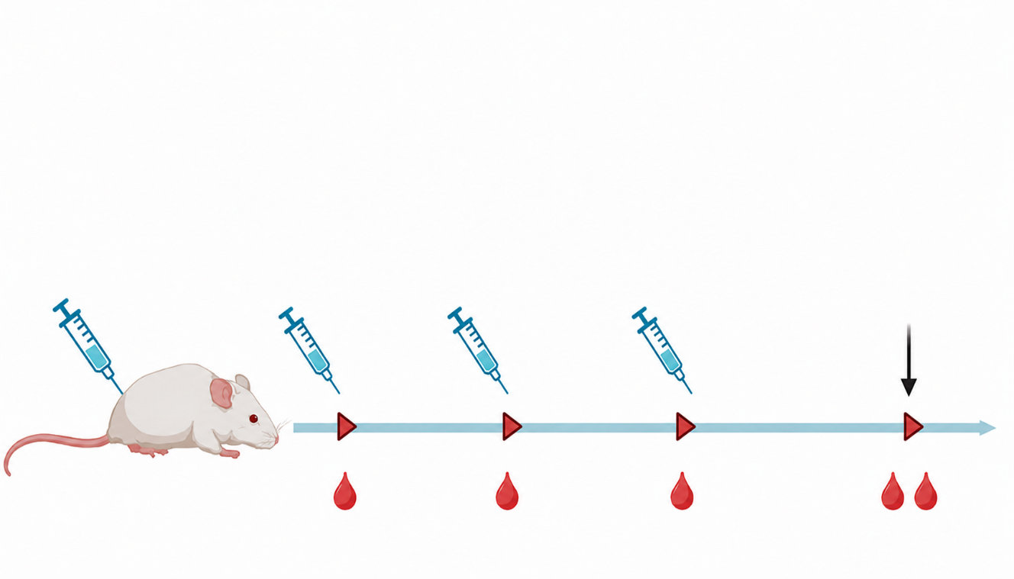
Booster Dose
Priming Dose
sacrifice
3rd dose
2nd dose
1st dose
- Formulate doses by adding the required volumes of buffer, deionized water, and protein stock. To mix, pipette. Never vortex.
- Each dose in this experiment contained 30µg/100µl/mice. (The dosing can vary according to experiment design)

- Blood sample collection:
- Collect 15 - 20 μL of blood through tail-bleeding, process them, and store them as 50x diluted mouse antisera. These mouse antisera will be the pre-immunization tail bleed samples, collected at least 3 days before first immunization.
- Immunize with the first dose and collect the first tail-bleed (TB) at day 7. Collect the second and third tail-bleed at day 14 and 21.
- Immunize the second dose at day 28 and collect tail bleed three times at 7-day intervals.
- Immunize with the third dose at day 56 and collect tail bleed two times at 7-day intervals.
- Make sure to calculate antibody titer via ELISA before each immunization.
- Sacrifice mice at day 77 and collect heart blood and spleen for further analysis via flow cytometry or qRT-PCR.

